**MODULE 4: FORECAST COMPONENTS**

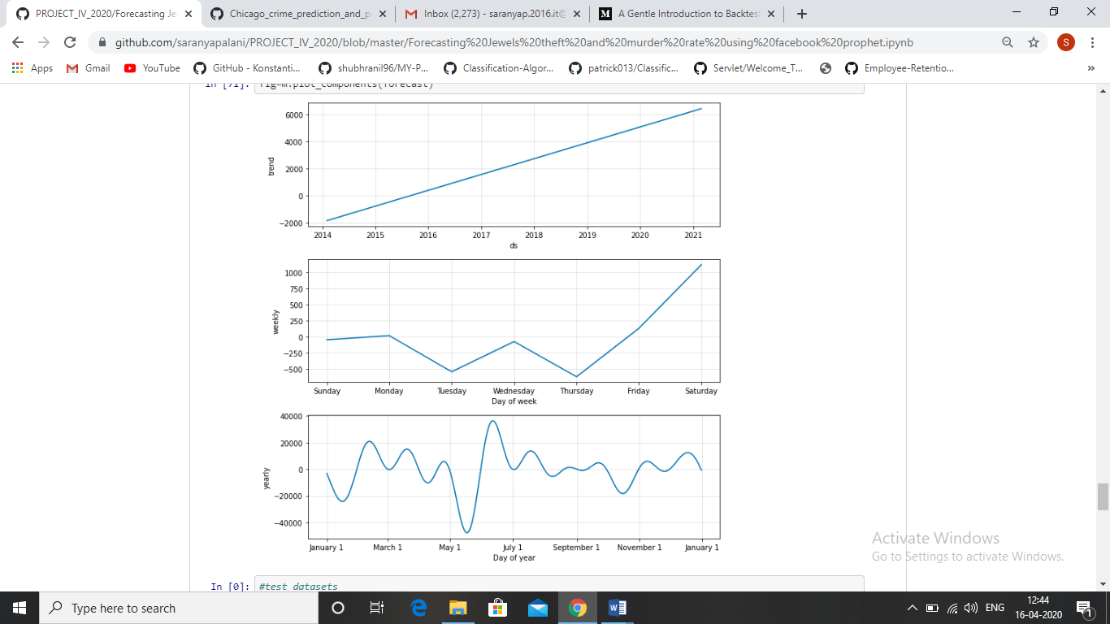

Figure 5